Particular | Details
Project Name | AI-Enabled Student Admission System
Team ID | SWITD-2026-9625
Submission Date | 26-06-2026
Maximum Marks | 100 Marks
Duplicate Management Configuration
Introduction
Duplicate Management in Salesforce helps identify and prevent duplicate records during creation or modification.
In the AI-Enabled Student Admission System, duplicate prevention was implemented for:
- Student Records (Contact Object)
- Student Enrollment Records
Matching Rules are used to identify possible duplicate records, while Duplicate Rules define the actions Salesforce should perform when duplicates are detected.

4.4 Creating Custom Matching Rule for Student (Contact)
Objective
To ensure that every student record is unique using Email and Phone Number.

Configuration Details
Object: Contact
Matching Rule Name:
Unique Student – Email & Phone
Matching Criteria
Field | Matching Method
Email | Exact
Phone | Exact

Steps Performed
- Navigate to:
Setup → Matching Rules
- Click:
New Rule
- Select Object:
Contact
- Enter Matching Rule Name:
Unique Student – Email & Phone
- Configure matching criteria:
- Email → Exact Match
- Phone → Exact Match
- Enable:
Match Blank Fields
- Save and Activate the rule.

📷 Figure 4.1 – Student Contact Matching Rule
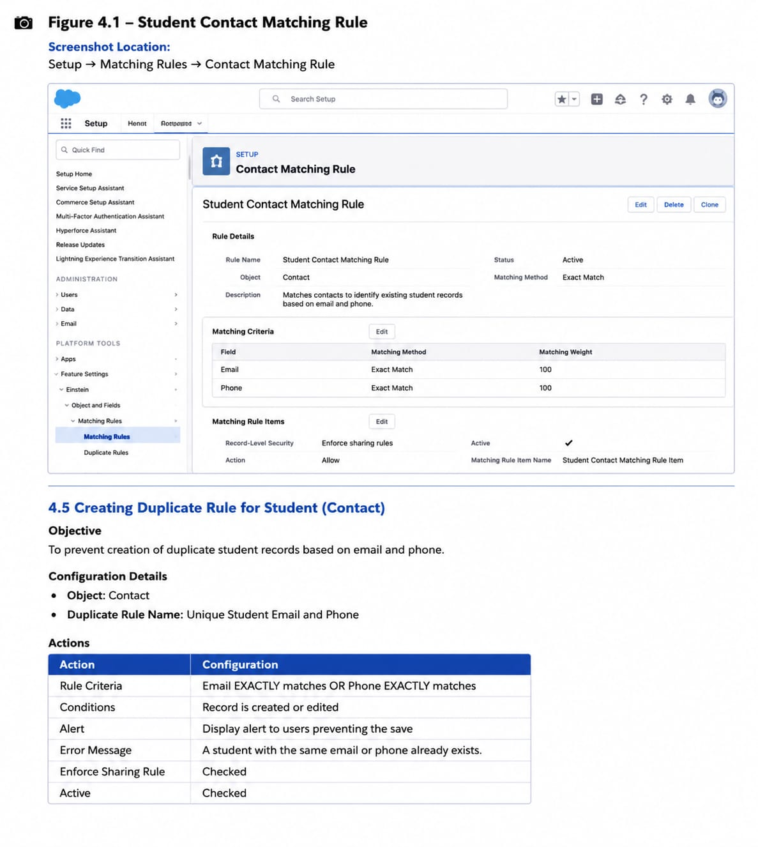
4.5 Creating Duplicate Rule for Student (Contact)
Objective
To prevent creation of duplicate student records based on email and phone number.

Configuration Details
Object: Contact
Duplicate Rule Name:
Unique Student Email and Phone
Actions
Action | Configuration
Create Action | Allow and Report
Edit Action | Allow and Report

Alert Message
"Student Email and Phone Number must be unique."

Steps Performed
- Navigate to:
Setup → Duplicate Rules
- Click:
New Rule
- Select:
Contact Object
- Add Matching Rule:
Unique Student – Email & Phone
- Configure duplicate actions.
- Save and Activate.

📷 Figure 4.2 – Contact Duplicate Rule
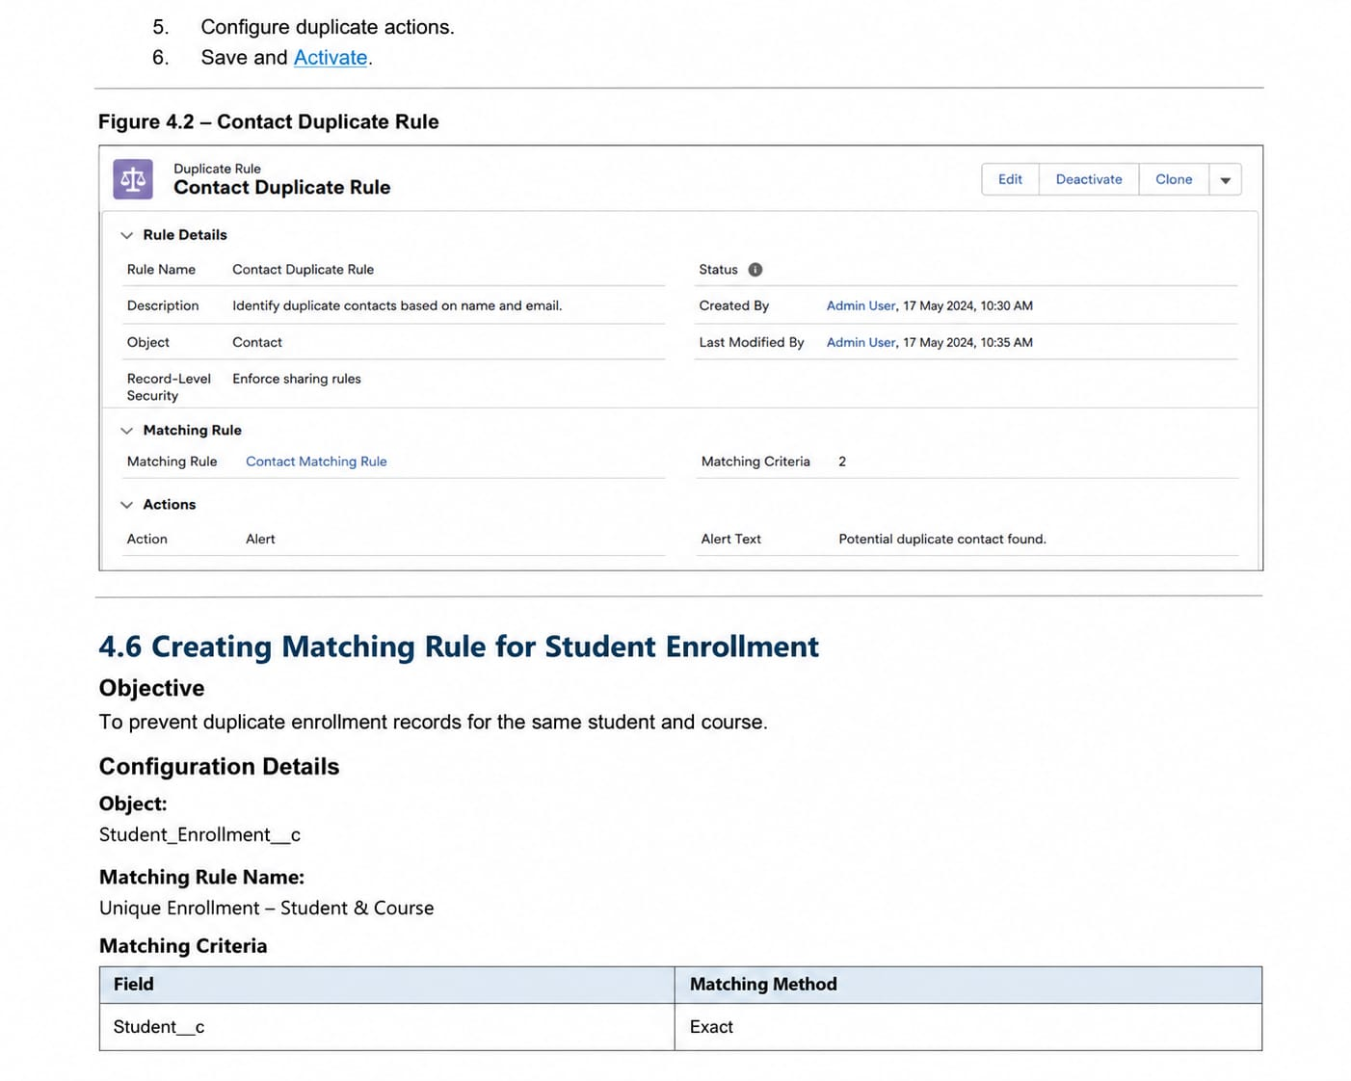

4.6 Creating Matching Rule for Student Enrollment
Objective
To prevent duplicate enrollment records for the same student and same course.

Configuration Details
Object:
Student_Enrollment__c
Matching Rule Name:
Unique Enrollment – Student & Course

Matching Criteria
Field | Matching Method
Student__c | Exact
Course__c | Exact

Steps Performed
- Open:
Setup → Matching Rules
- Click:
New Rule
- Select Object:
Student_Enrollment__c
- Enter Rule Name:
Unique Enrollment – Student & Course
- Configure matching fields:
- Student Lookup → Exact
- Course Lookup → Exact
- Save and Activate.

📷 Figure 4.3 – Student Enrollment Matching Rule
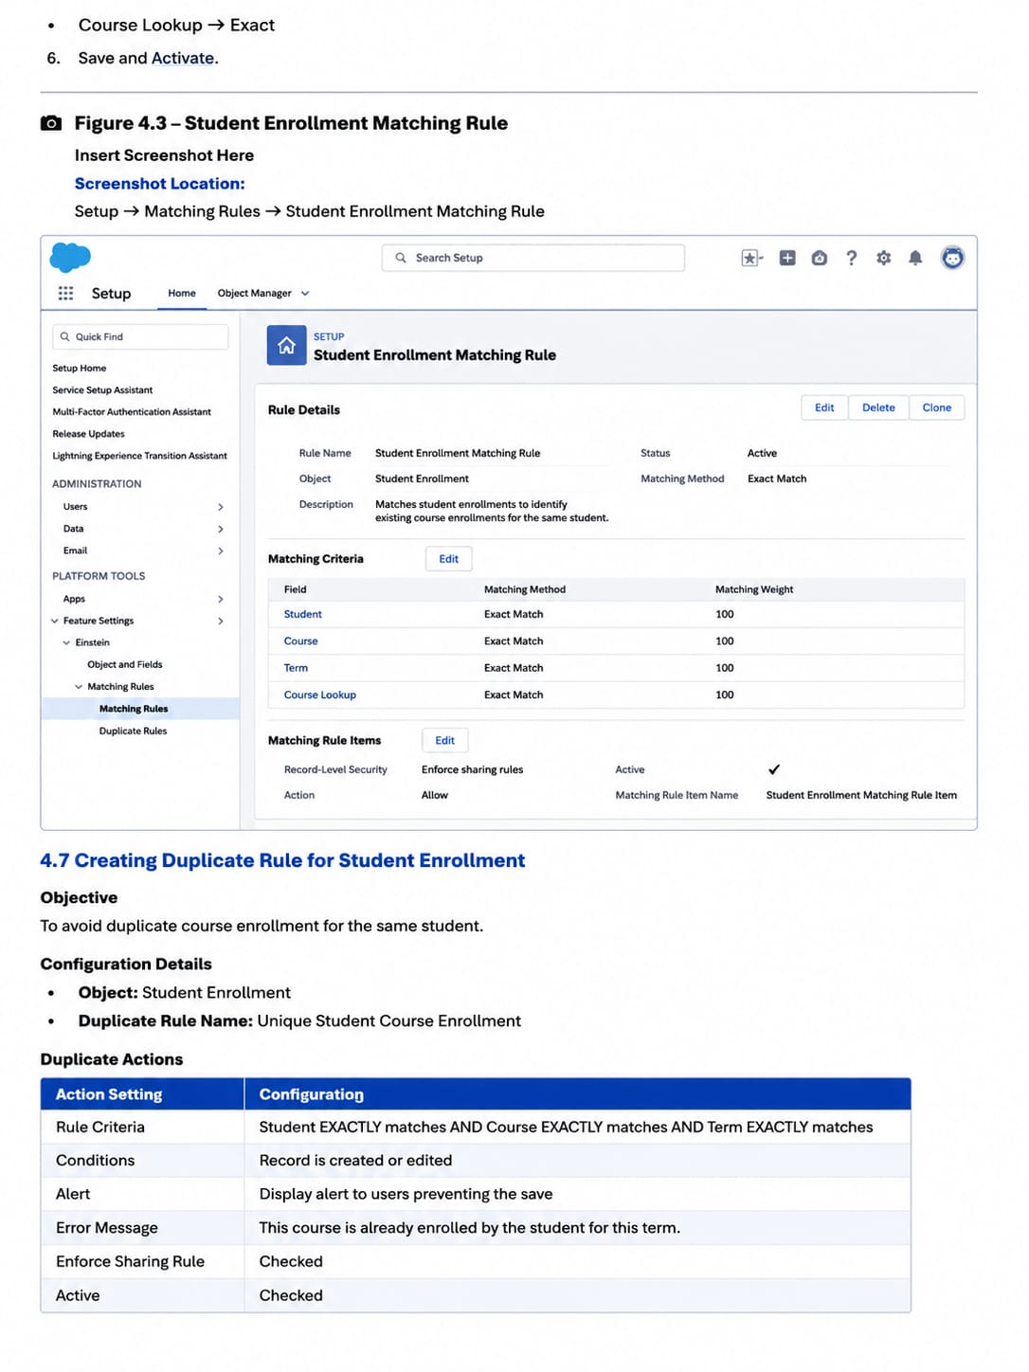

4.7 Creating Duplicate Rule for Student Enrollment
Objective
To avoid duplicate course enrollment for the same student.

Configuration Details
Object:
Student_Enrollment__c
Duplicate Rule Name:
Unique Student Course Enrollment

Duplicate Actions
Action | Setting
Create | Allow and Report
Edit | Allow and Report

Alert Message
"This student is already enrolled in the selected course."

Steps Performed
- Open:
Setup → Duplicate Rules
- Select:
Student_Enrollment__c
- Add Matching Rule:
Unique Enrollment – Student & Course
- Save and Activate.

📷 Figure 4.4 – Enrollment Duplicate Rule
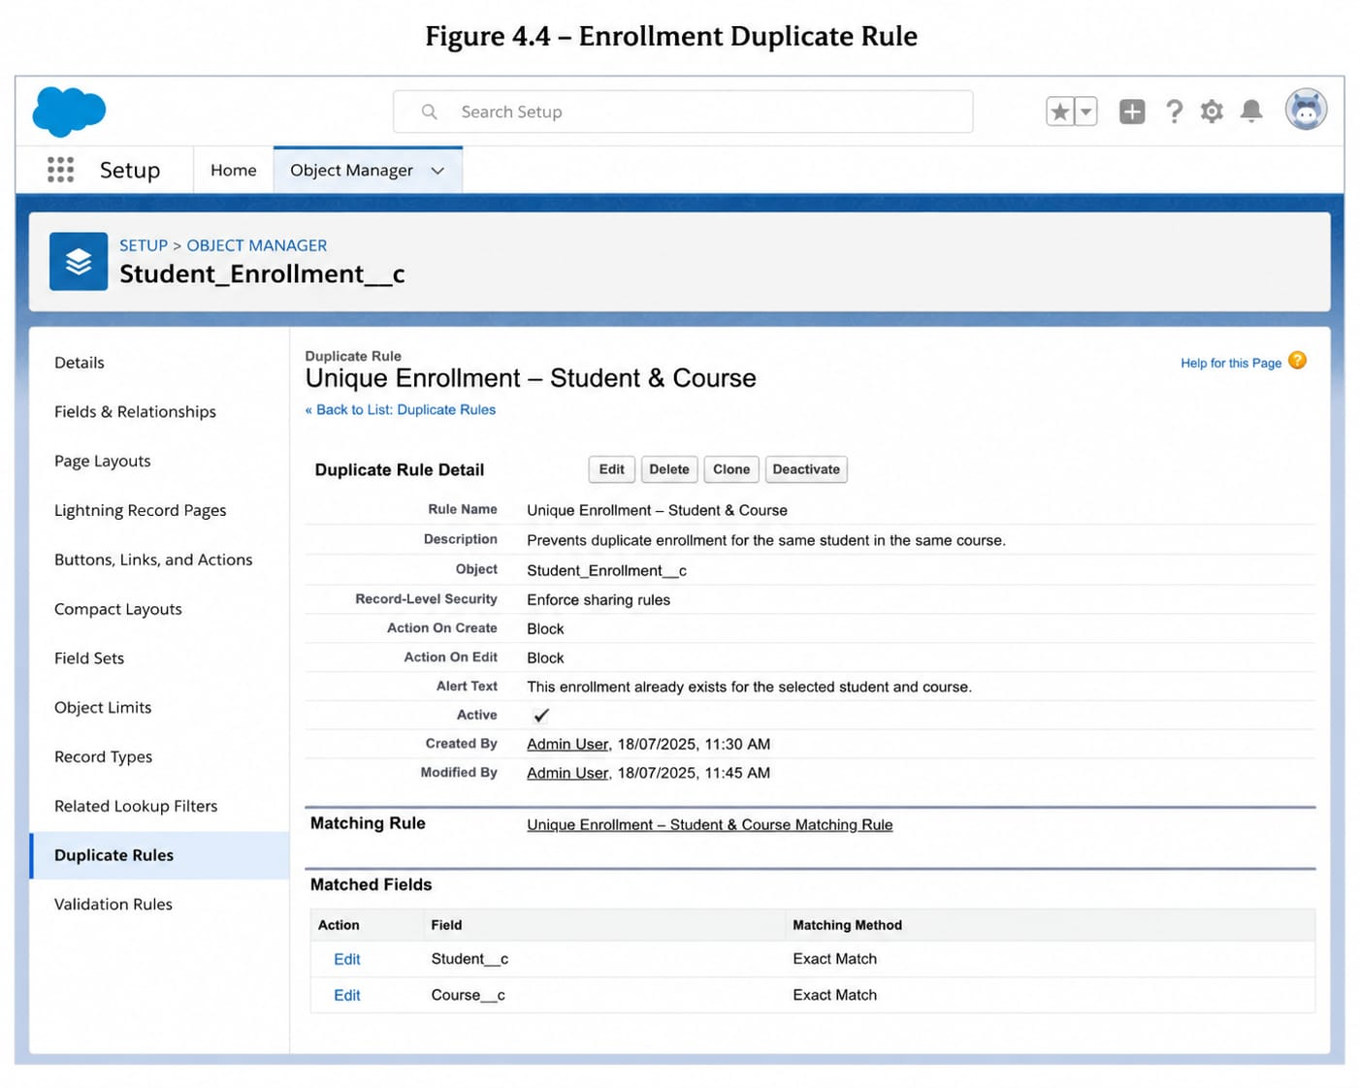

4.8 Salesforce Profile Configuration
Introduction
A Salesforce Profile defines user permissions and controls what actions a user can perform.
Profiles control:
- Object permissions
- Field permissions
- User permissions
- Tab visibility
- Application access
- Record access settings
In this project, custom profiles were created for:
- Admission Counselor
- Admission Manager

4.9 Admission Counselor Profile Creation
Objective
To provide counselors with required permissions for managing student applications and enrollments.

Profile Configuration
Profile Name:
Admission Counselor Profile
Created By:
Cloning Standard User Profile

Object Permissions
Object | Permission
Contact | Read/Create/Edit
Student Enrollment | Read/Create/Edit
Course | Read/Create/Edit
Task | Read/Create/Edit
Reports | Read Only
Dashboards | Read Only

AI Access
Read Access:
- AI Priority Score
- Risk Level
Restrictions:
- No approval permission
- No override access

Password Policies
- Password Expiry: 90 Days
- Minimum Password Length: 8 Characters
- Session Timeout: 2 Hours

📷 Figure 4.5 – Admission Counselor Profile
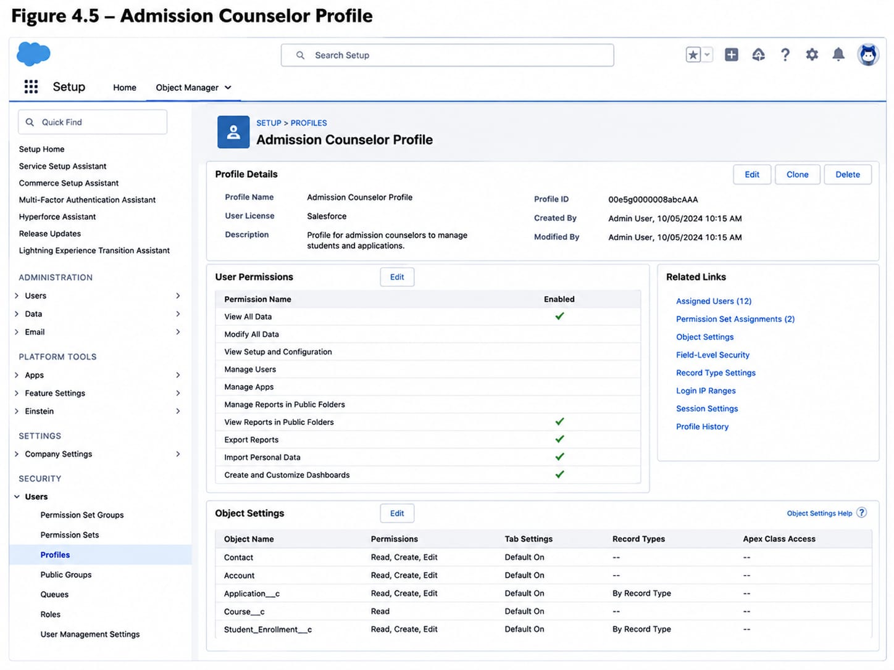

4.10 Admission Manager Profile Creation
Objective
To provide managers with higher-level access for approvals and admission monitoring.

Profile Name
Admission Manager Profile

Permissions
Admission Managers can:
- View counselor records
- Review discount approvals
- Analyze AI recommendations
- Approve or reject enrollment requests
- Access reports and dashboards

📷 Figure 4.6 – Admission Manager Profile
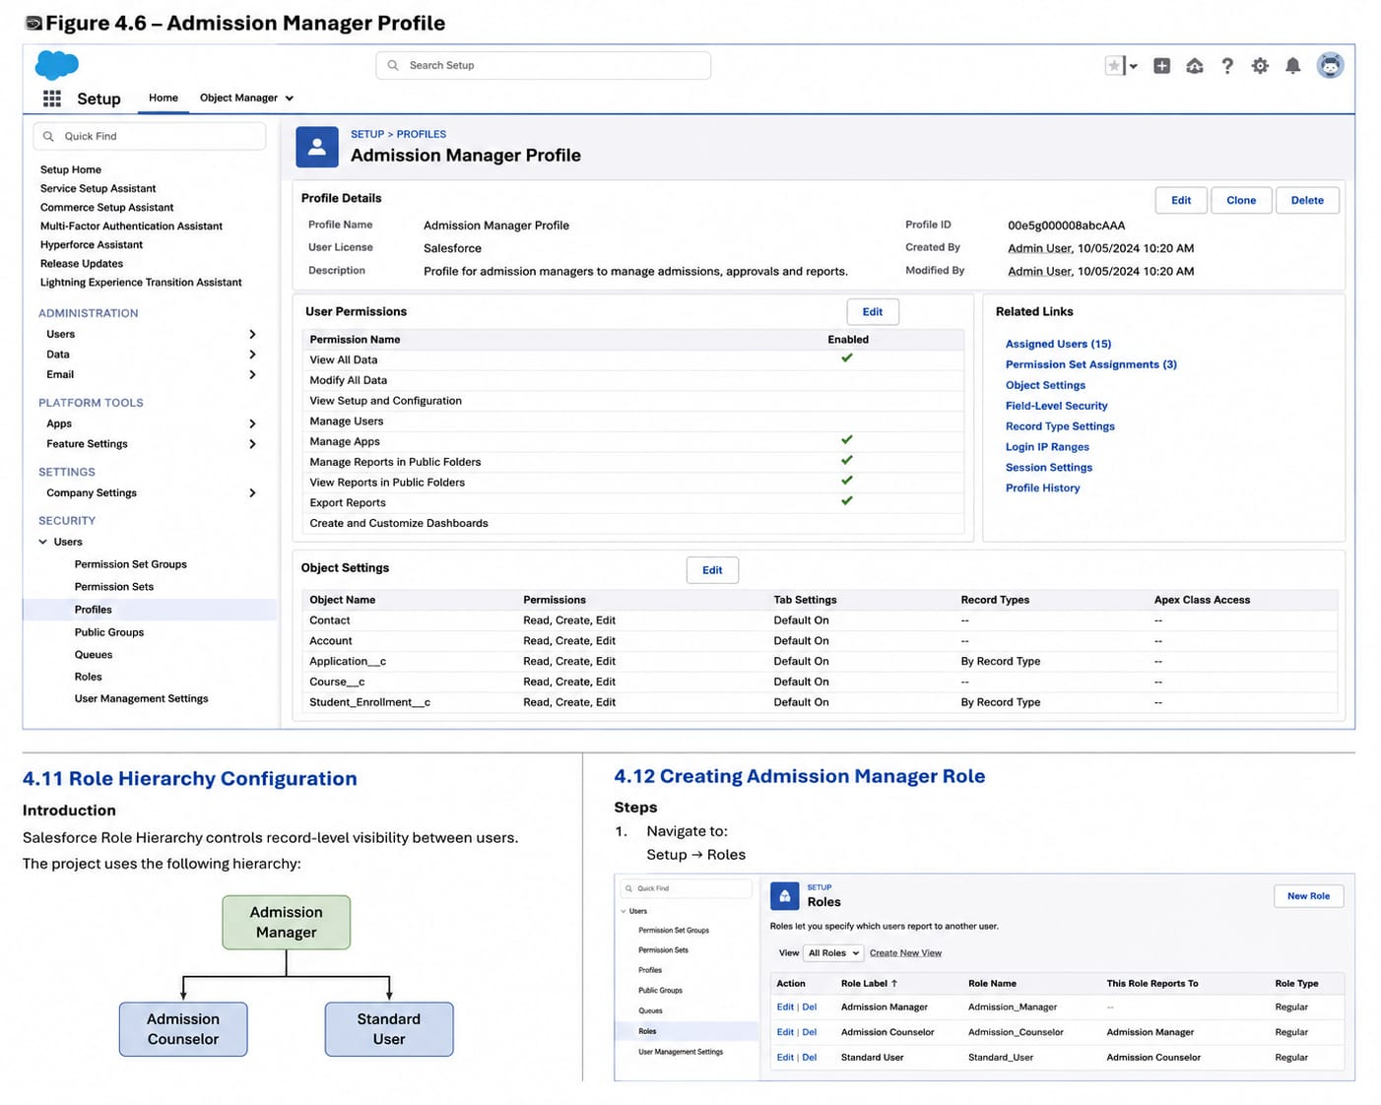

4.11 Role Hierarchy Configuration
Introduction
Salesforce Role Hierarchy controls record-level visibility between users.
The project uses the following hierarchy:
Admission Manager

↑

Admission Counselor

4.12 Creating Admission Manager Role
Steps
- Navigate to:
Setup → Roles
- Click:
Add Role
- Enter:
Role Label:
Admission Manager
- Save.

📷 Figure 4.7 – Admission Manager Role
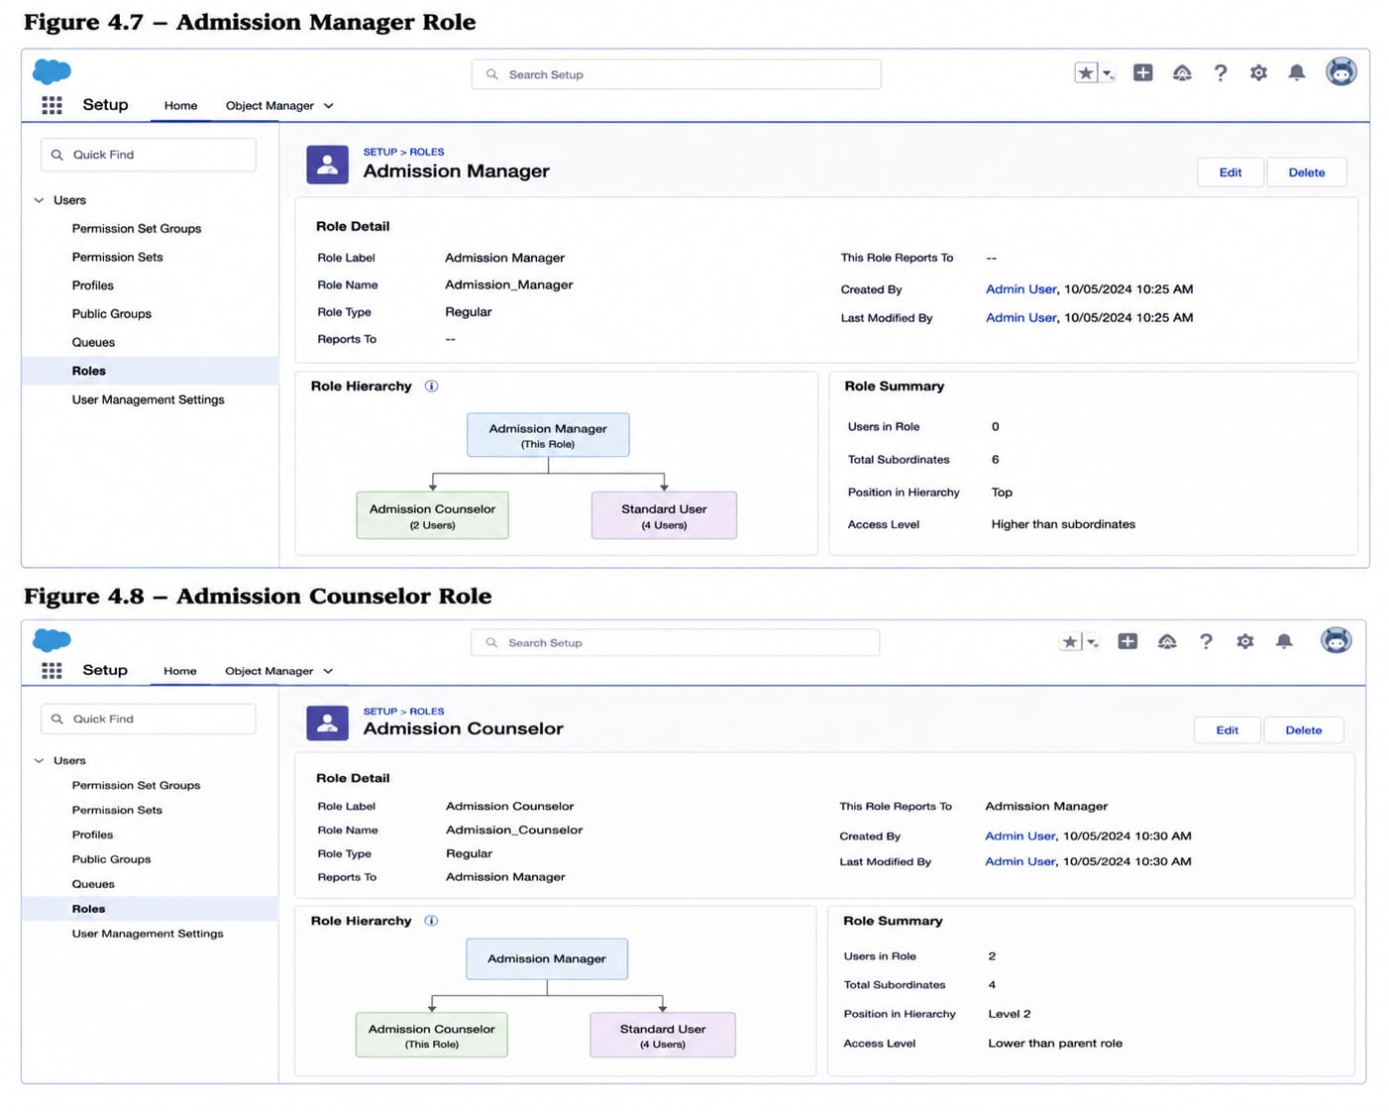

4.13 Creating Admission Counselor Role
Steps
- Open Role Hierarchy.
- Click Add Role under Admission Manager.
- Enter:
Role Label:
Admission Counselor
- Save.

Here 📷 Figure 4.8 – Admission Counselor Role
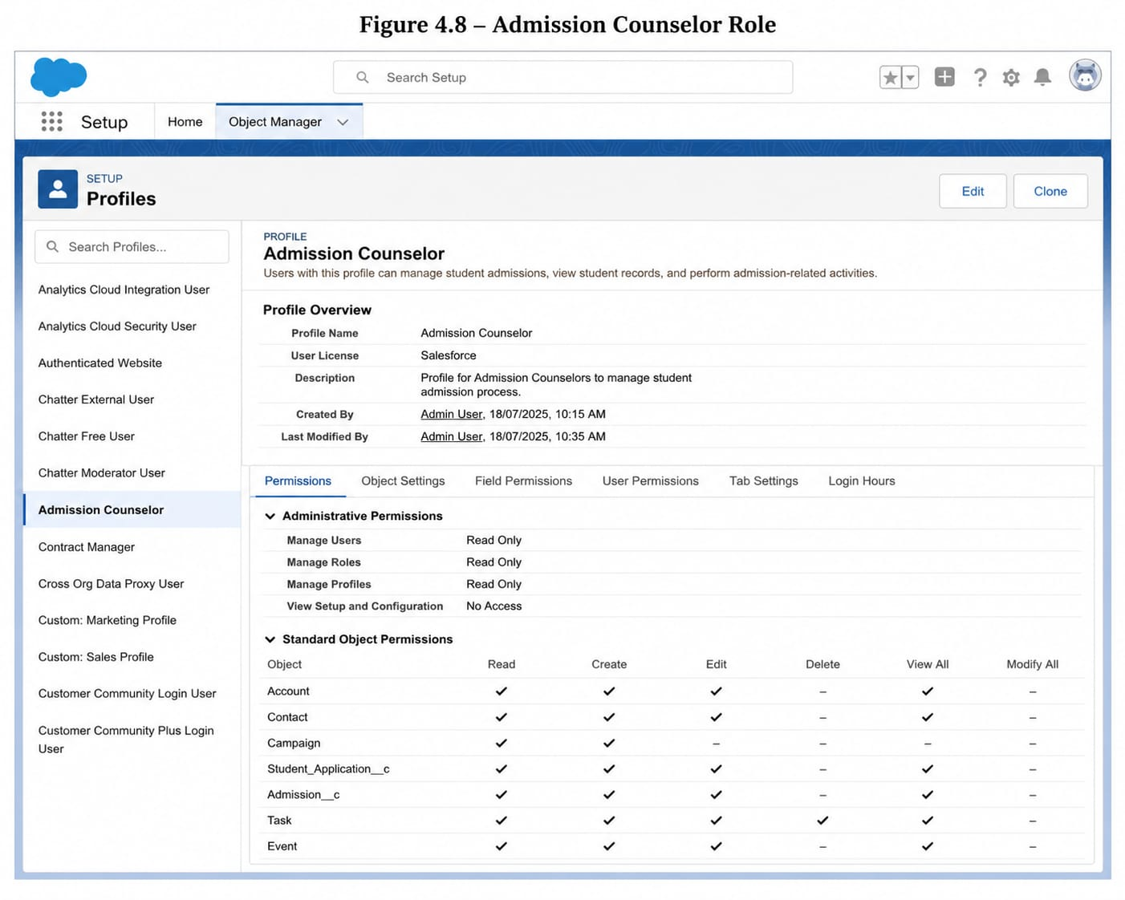

Team Information
Team ID : SWTID-2026-9625
Team Size : 5
Team Leader : Gayathri Pemmanaboyidi
Team member : Anitha Kumari Seekolu
Team member : Aditya Vardhan Katta
Team member : Jaswanth Srikar Addanki
Team member : Sontenam Santosh Venkat Charan

S.No | Role | Full Name | Email ID
1 | Team Lead | Gayathri Pemmanaboyidi | gayathridevipemmanaboyidi@gmail.com
2 | Team Member | Anitha Kumari Seekolu | seekoluanitha13@gmail.com
3 | Team Member | Aditya Vardhan Katta | kattaadityavardhan@gmail.com
4 | Team Member | Jaswanth Srikar Addanki | jaswanthsrikar56@gmail.com
5 | Team Member | Sontenam Santosh Venkat Charan | ssvcharan414@gmail.com

